SQL Lesson 1: SELECT queries 101

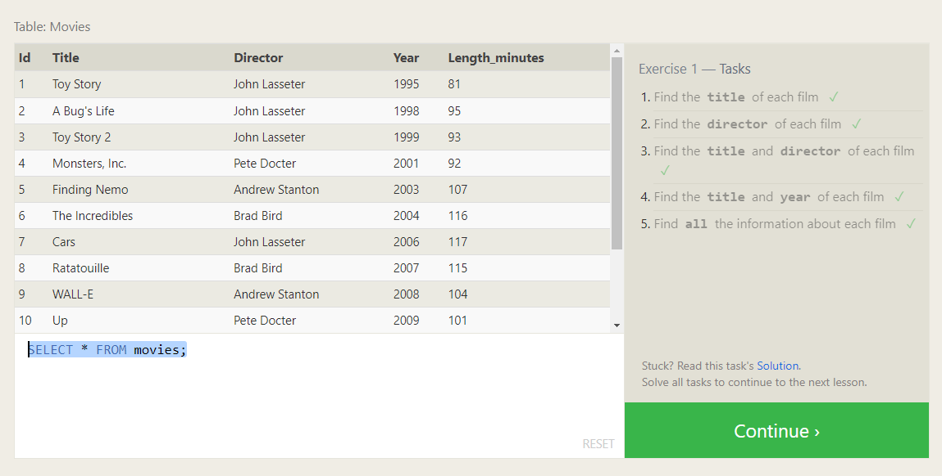

1. SELECT title FROM movies;
2. SELECT director FROM movies;
3. SELECT title, director FROM movies;
4. SELECT title, year FROM movies;
5. SELECT * FROM movies;

SQL Lesson 2: Queries with constraints (Pt. 1)

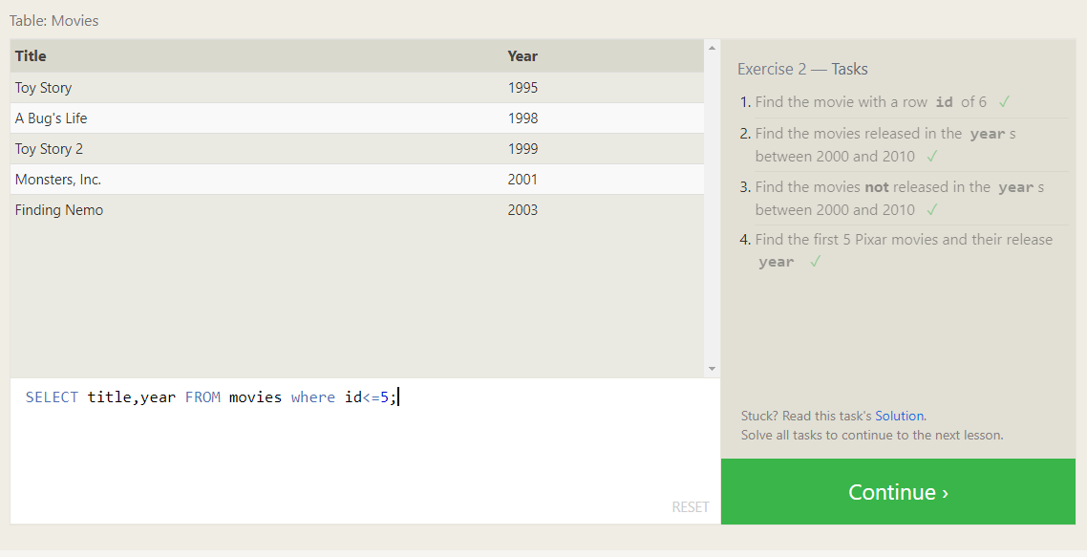

1. SELECT * FROM movies where id=6;
2. SELECT * FROM movies where year between 2000 and 2010;
3. SELECT * FROM movies where year not between 2000 and 2010;
4. SELECT title, year FROM movies where id<=5;

SQL Lesson 3: Queries with constraints (Pt. 2)

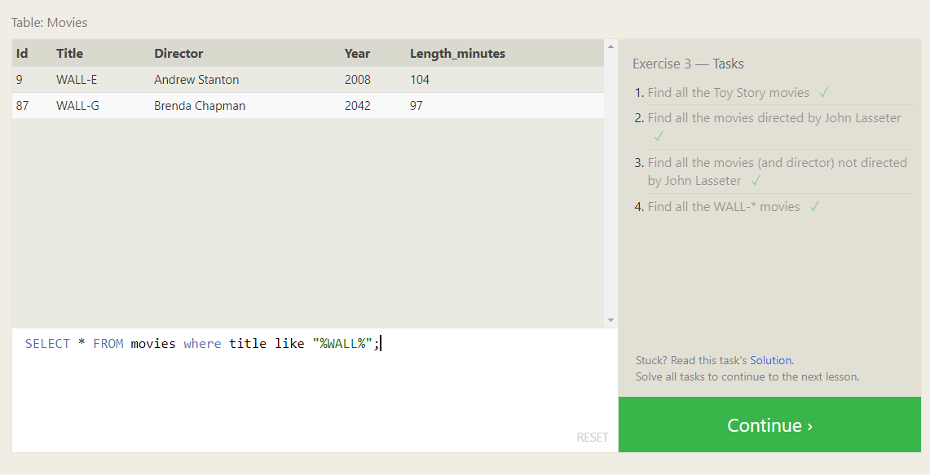

1. SELECT * FROM movies where title like "%toy story%";
2. SELECT * FROM movies where director like "%John Lasseter%";
3. SELECT title, director FROM movies where director!="John Lasseter";
4. SELECT * FROM movies where title like "%WALL%";

SQL Lesson 4: Filtering and sorting Query results

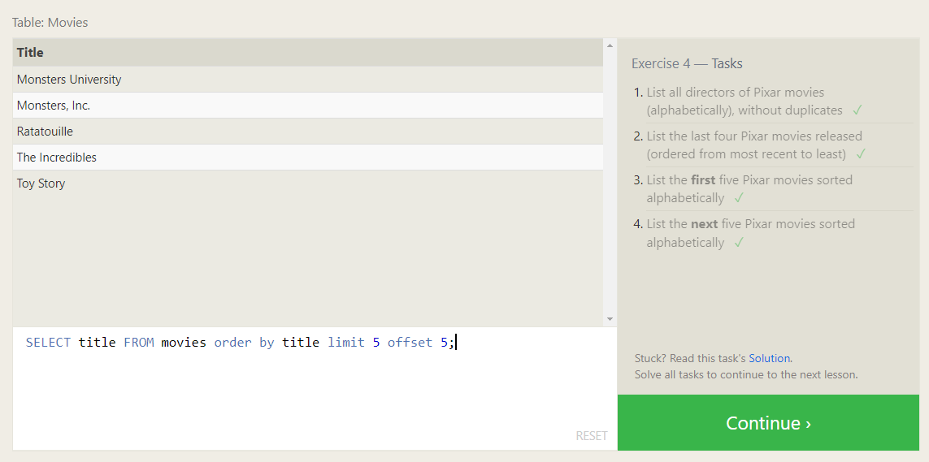

1. SELECT distinct director FROM movies order by director asc;
2. SELECT distinct title FROM movies order by year desc limit 4;
3. SELECT distinct title FROM movies order by title asc limit 5;
4. SELECT title FROM movies order by title limit 5 offset 5;

SQL Review: Simple SELECT Queries

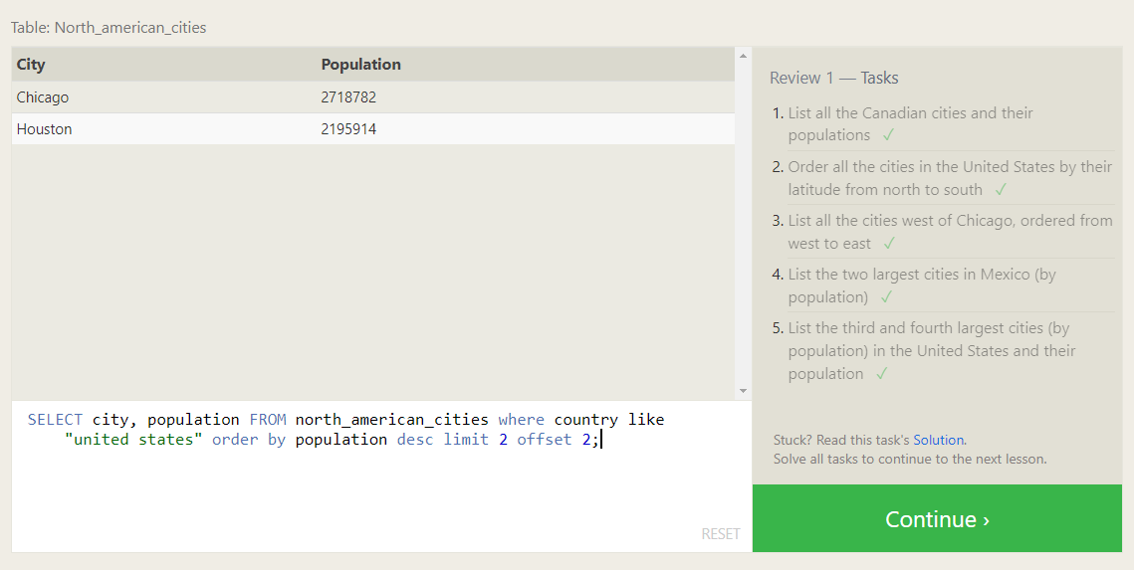

1. SELECT city, population FROM north_american_cities where country like"canada";
2. SELECT city FROM north_american_cities where country like "united states" order by latitude desc;
3. SELECT city FROM north_american_cities where longitude < -87.629798 order by longitude asc;
4. SELECT city FROM north_american_cities where country like "mexico" order by population desc limit 2;
5. SELECT city, population FROM north_american_cities where country like "united states" order by population desc limit 2 offset 2;

SQL Lesson 6: Multi-table queries with JOINs

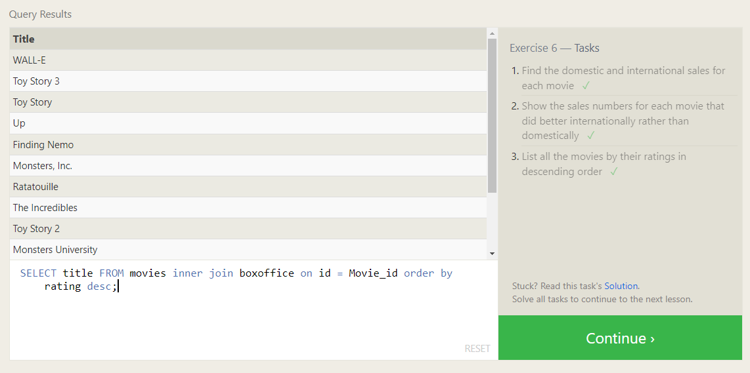

1. SELECT title,Domestic_sales,International_sales FROM movies inner join boxoffice on id = Movie_id;
2. SELECT title,Domestic_sales,International_sales FROM movies inner join boxoffice on id = Movie_id where International_sales>Domestic_sales;
3. SELECT title FROM movies inner join boxoffice on id = Movie_id order by rating desc;

SQL Lesson 7: OUTER JOINs

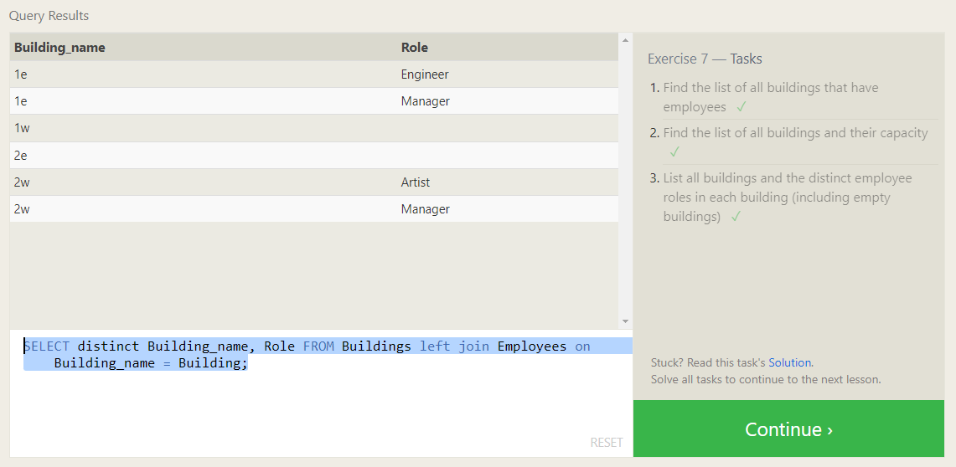

1. SELECT distinct building FROM employees;
2. SELECT * FROM Buildings;
3. SELECT distinct Building_name, Role FROM Buildings left join Employees on Building_name = Building;